**Mid-Term Exam Grammar Review**

Indirect Questions:

Change the following to indirect questions:

1. Why did you install it there?
2. Where are you going?
3. Is it easy to use?
4. Where does he live?

Change the following to direct questions:

1. Could you tell me how to do the project?
2. Can you explain why it is broken?
3. I wonder if he made that program.

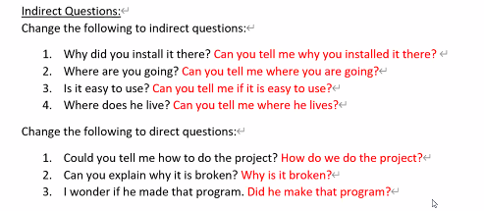

Necessity:

We are looking for a systems manager to work for our company. The following are the job requirements:

* Technical specialist
* Minimum 2 years’ experience
* Computer science degree not required
* Strong writing skills

Look at the job advertisement and write four sentences using the prompts:

1. (must) _________________________________
2. (need to) _________________________________
3. (have to) _________________________________
4. (essential) _________________________________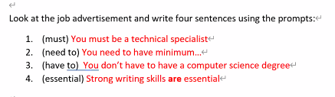

Adverbs of Frequency:

Complete the sentences with an appropriate adverb of frequency

1. He lives next door, so I _______ see him.
2. Nancy and I _____ (30%) go out for coffee.
3. It _____ (2%) rains here in the summer.
4. I have a meeting with my manager ______

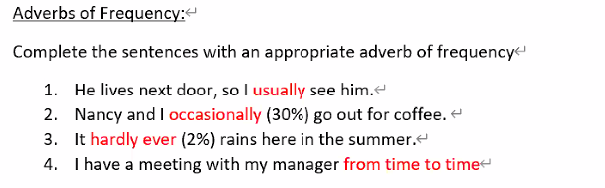

Articles:

I have ____ big assignment due tomorrow. ___ assignment is to imagine I am applying to ____ company for a job and I have to make ____ resume. ___ professor said that ____ resume must look professional, so I looked online to find ____ example of a nice-looking resume.

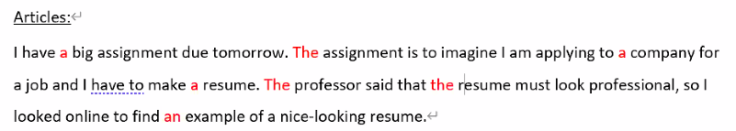

Crossword

